Guru99 demo
Demo testing website
Test Summary Report
Project Name | Guru99 demo testing
Application URL | https://demo.guru99.com
Document Version | 1.1
Document Status | Final
Prepared By | Ameer Suhail TK
Reviewed By | Greeshma
Approved By | Alka
Date | 13-Sep-2026

1. Objective of Testing
To validate that the critical functionalities of the Guru99 demo testing website — home page navigation, page UI /Actions, input data validation, and submission — work as expected, are free of critical defects, and provide a smooth end-to-end shopping experience.

2. Scope of Testing
In-Scope
- Home page navigation, banners, category shortcuts, footer links
- Login validation, registration, input data, and payment gateway pages
- UI actions, Page detention, and quality management
- Cart subtotal, tax, Checkout, and discount handling
- User bill creation and get usage queries, ID validation (during bill staging)
- Flight finder is available to get real data
Out-of-Scope
- Real-time integration with third-party payment systems
- SEO testing
- Bug detection corrections

3. Test Environment
- Application Under TestGuru99 (https://demo.guru99.com)
- Browsers Used: Chrome, Firefox, Edge
- Test Type: UAT testing

4. Test Artefacts Created
- Test Cases (Guru99 Microsoft Excel Worksheet (.xlsx) — Test Cases sheet)
- Defect Log (Guru99 Microsoft Excel Worksheet (.xlsx)— Defects sheet)
- Test Execution Summary & charts (Test Summary sheet)
- Test Report
- Test Sign-Off Document

5. Testing Types Performed
- Functional Testing
- UI Testing
- Input Validation Testing
- Regression-style re-checks on repeated scenarios (e.g., quantity sync, discount codes)
- Exploratory and performance testing

6. Defect Summary
Severity | No. of Defects | Status
Critical | 51 | Open
Major | 2 | Open
Moderate | 12 | Open
Cosmetic | 16 | Open
Total | 81 | Open
Note: This cycle's workbook does not track a fix/close workflow, so all logged defects are reported as Open at the time of this report.
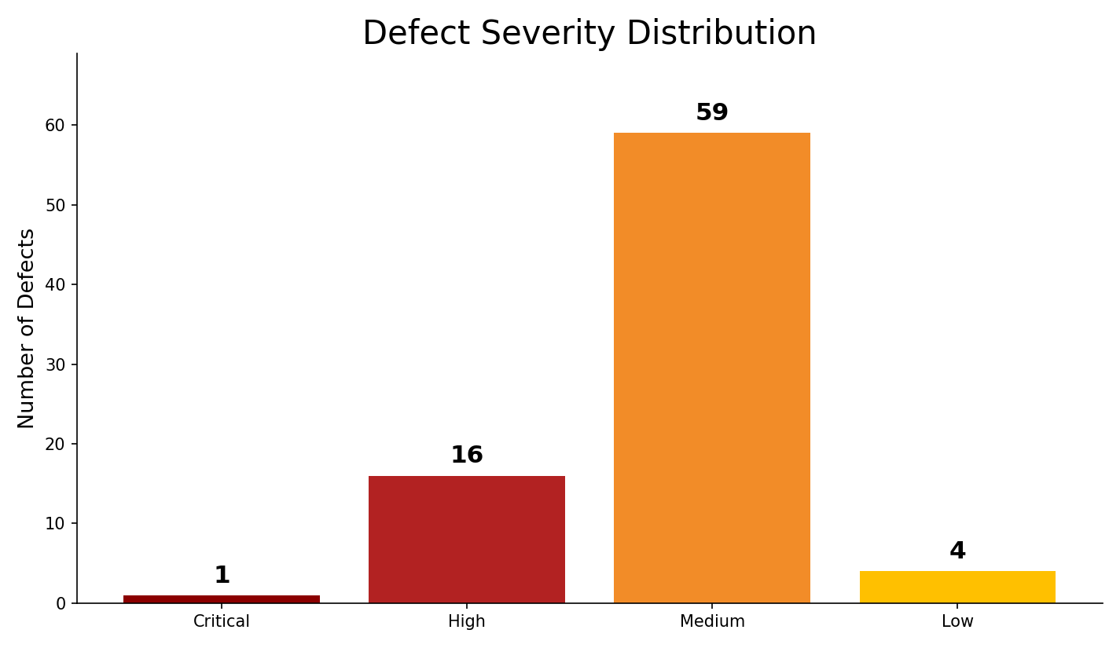

7. Test Metrics Summary
Item | Count
Total Test Cases Designed | 383
Total Test Cases Executed | 383
Test Cases Passed | 303
Test Cases Failed | 80
Test Cases Not Executed | 0
Defects Reported | 80
Defects Closed | 0

8. Test Schedule and Duration
Detailed test-planning and execution dates were not tracked in the source workbook for this cycle; QA Led to populate before final distribution:
- Test Planning Start: 13 Aug 26
- Test Execution Period: 20 Aug 26 to 10 Sep 26
- Total Duration: 22 Days

9. Risks and Issues
- The Product module carries the largest concentration of defects (40 of 80) and the lowest pass rate (41.2%), indicating instability in sorting, filtering, and product-detail functionality.
- A Critical-severity defect (CART-015) allows checkout to proceed on items whose stock has depleted, risking backend fulfilment failures.
- Several CheckOut validation gaps (invalid email, expired card, invalid CVV) allow orders to be placed with bad input data.
- Duplicate order submissions are not reliably blocked (BUG_CO-010), risking customers being charged twice.

10. Test Results Summary
- 141 of 221 test cases passed (63.8% overall pass rate).
- Home Page and Cart modules are comparatively stable (75.0% and 78.9% pass rate).
- Product module requires the most rework before re-test (41.2% pass rate).
- One Critical and 10 Blocking-priority defects remain open.

11. Conclusion & Recommendation
The Polymer Shop application has not yet met the acceptance bar for release: the overall fail rate (36.2%) and the presence of a Critical-severity, Blocking-priority defect in the Cart/CheckOut flow both indicate meaningful functional risk. The QA team recommends a focused defect-fix cycle — prioritizing the Critical and Blocking items — followed by a full regression pass, before this build is considered for a GO-LIVE decision.

